**Coding Assignment**

**Name:** Jeevan Sai Badana

Mail: [jeevansai100@gmail.com](mailto:jeevansai100@gmail.com)

Date : 02-02-2024

2. Execute with one example Lambda Functions in Python & Read JSON Strings to Python dicts or lists

**Lambda Function:**

* Lambda functions in Python are anonymous functions that can have any number of input parameters but can only have one expression
* They are often used for short, simple operations.

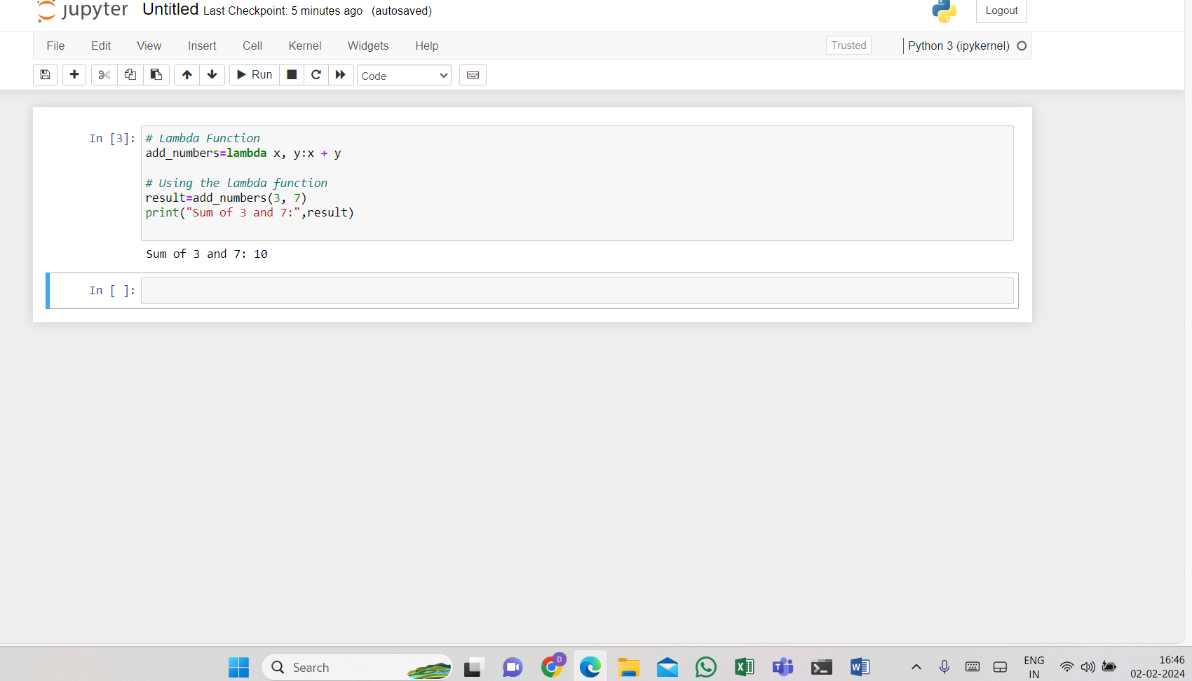

**Read JSON Strings to Python dicts or lists:**

For this purpose first we import json and then by using json.loads we can convert Json Strings to python lists

Here is the following code

